
DEPARTMENT OF

COMPUTER

Experiment 1
Student Name:Riya Kashyap UID: 25MCA20033
Branch: MCA-UIC Section/Group: 1
Semester: 2nd Date of Performance:7/1/2026
Subject Name: Technical Training Subject Code: 25CAP-652

Aim of the Project
The aim of this project is to design and implement a relational database system using SQL by creating multiple tables with appropriate constraints, performing data manipulation operations, managing access control through roles, and modifying the database schema to ensure data integrity and security.

Objective of the Project
- To understand the creation of relational database tables using SQL.
- To apply primary key, foreign key, unique, and check constraints.
- To perform data manipulation operations such as INSERT, UPDATE, and DELETE.
- To implement role-based access control in a database system.
- To modify and manage database schema using ALTER and DROP commands.

Practical / Experiment Steps
- Design relational database tables with appropriate attributes.
- Apply constraints such as PRIMARY KEY, FOREIGN KEY, UNIQUE, and CHECK.
- Insert sample records into tables.
- Perform UPDATE and DELETE operations on records.
- Create database roles for access control.
- Grant and revoke permissions to users.
- Modify table structure using ALTER command.

Procedure of the Practical
TABLE CREATION
CREATE TABLE department (
dept_id INT PRIMARY KEY,
dept_name VARCHAR(50) NOT NULL UNIQUE
);
CREATE TABLE employee (
emp_id INT PRIMARY KEY,
emp_name VARCHAR(20) NOT NULL,
salary NUMERIC(10,2) CHECK (salary > 0),
dept_id INT NOT NULL,
CONSTRAINT fk_department FOREIGN KEY (dept_id) REFERENCES department(dept_id)
);
CREATE TABLE project (
project_id INT PRIMARY KEY,
project_name VARCHAR(100) NOT NULL,
dept_id INT NOT NULL,
CONSTRAINT fk_project FOREIGN KEY (dept_id) REFERENCES department(dept_id)
);
DATA INSERTION
INSERT INTO department VALUES (1, 'HR'), (2, 'IT');
INSERT INTO employee VALUES
(101, 'Rohit Batra', 50000, 2),
(102, 'Riya Kashyap', 65000, 1);
INSERT INTO project VALUES
(201, 'Employee Portal', 2),
(202, 'Payroll System', 1);
UPDATE OPERATION
UPDATE employee
SET salary = salary + 5000
WHERE emp_id = 102;
DELETE OPERATION
DELETE FROM project
WHERE project_id = 201;
ACCESS CONTROL
CREATE ROLE team_leader WITH LOGIN PASSWORD 'leader@123';
GRANT SELECT ON department TO team_leader;
GRANT SELECT ON employee TO team_leader;
GRANT SELECT ON project TO team_leader;
REVOKE CREATE ON SCHEMA public FROM team_leader;
SCHEMA MODIFICATION
ALTER TABLE employee ADD COLUMN experience INT;
DROP TABLE project;
VERIFICATION QUERIES
SELECT * FROM department;
SELECT * FROM employee;
SELECT CURRENT_USER;

I/O Analysis

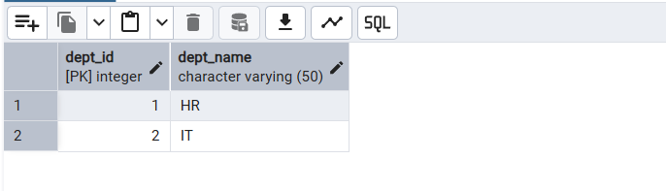

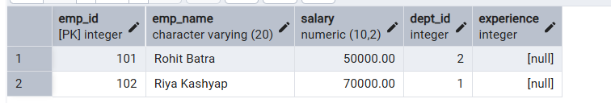

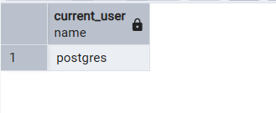

Learning Outcome
- Understanding of relational database design.
- Knowledge of SQL constraints and table relationships.
- Practical experience in data manipulation operations.
- Hands-on exposure to role-based access control.
- Ability to modify and manage database schema.

